Fluid Flow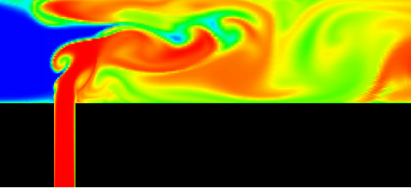

Contents

1 Introduction 4

2 Bernoulli’s Equation 4

2.1 Elevation Change Component 5

2.2 Friction Loss Component 5

2.3 Acceleration Component 5

3 Fluid Statics 6

3.1 Incompressible Fluid 6

3.2 Compressible Fluid 6

4 Flowing Fluids 7

4.1 Laminar Flow 7

4.2 Turbulent Flow 8

4.3 Reynolds Number 8

4.4 Boundary Layer 8

4.5 Viscosity 9

4.5.1 Force Balance and Velocity Distribution 9

4.5.2 Turbulent Flow 11

4.5.3 Friction Factor and Pipe Roughness 11

4.5.4 Equivalent Length 14

4.5.5 K Factors 15

4.5.6 Approximate Line Sizing 17

4.6 Control Valves 18

5 Compressible Flow Pressure Drop 19

6 Flow through an Orifice 22

7 Choke/Critical/Sonic Flow 24

8 Surge 25

8.1 Joukuowsky Equation 26

8.2 Surge in Pipelines 27

9 Pipeline Column Separation 29

10 Key Learnings 29

11 Reading List 29

# Introduction

Fluid flow underpins many aspects of Chemical and Petroleum Engineering. This module recaps earlier theory and presents fluid flow in a more practical context. Single phase compressible and incompressible flow together with some related phenomena are discussed.

# Bernoulli’s Equation

Bernoulli presented an energy balance as follows;

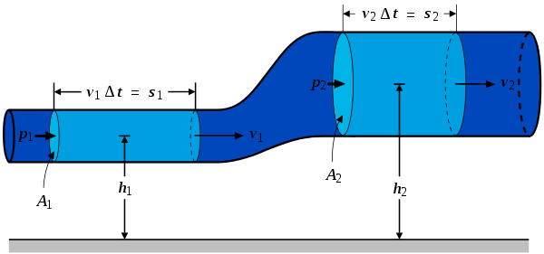

An inviscid fluid is transported as illustrated from P1 to P2.

The total energy change in the system is the change in Kinetic and Potential energy. The energy change will be the overall work done on the system.

The change in work done is the change in force x distance -

$$P_{1}A_{1}S_{1}- P_{2}A_{2}S_{2}$$

$$P_{1}V_{1}- P_{2}V_{2}$$

The change in Kinetic energy

$$\frac{M_{1}v_{1}^{2}}{2}- {\frac{M_{2}v_{2}^{2}}{2}}_{}$$

The change in Potential energy

$$ρ_{1}h_{1}g- {ρ_{2}h_{2}g}_{}$$

Conserving energy and substituting ρ = m/V

gives the Bernoulli equation;

2

2

2

2

1

2

1

1

2

2

*h*

*g*

*v*

*g*

*p*

*h*

*g*

*v*

*g*

*p*











**

**

In a real system the flowing fluids experience an irreversible loss of energy due the friction at the pipe wall – more later. This introduces a further pressure drop termed frictional losses.

Bernoulli’s equation in integral form for engineering application becomes;

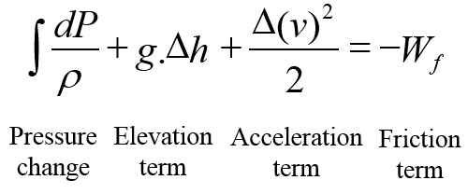

## Elevation Change Component

This component is zero for horizontal flow. It applies for compressible or incompressible, steady state or transient flow in both vertical and inclined flow. For downward flow the hydrostatic pressure increases in the direction of the flow.

## Friction Loss Component

This component applies for any type of flow at any pipe angle. Due to losses at the pipe wall it always causes a drop of pressure in the direction of flow. In laminar flow the friction losses are linearly proportional to the fluid velocity. In turbulent flow the friction losses are proportional to Vn, where n will be between 1.7 and 2.

## Acceleration Component

This component reflects the rate of change of velocity, hence it is zero for constant area, incompressible flow. For any flow condition in which a velocity increase occurs, such as compressible flow, a pressure drop will occur in the direction of the velocity increase.

If the fluid decelerates the pressure will increase.

# Fluid Statics

## Incompressible Fluid

Consider a vertical pipe containing a static incompressible fluid. Thus density does not vary with pressure.

A force balance yields;



*a* is the pipe area

Ps

h

h

h

P

## Compressible Fluid

Here the density will change with pressure.

Recap on gas law;



R – Universal Gas Constant

z – compressibility = 1 for ideal gas

n – no of moles

P – Pressure

T - Temperature

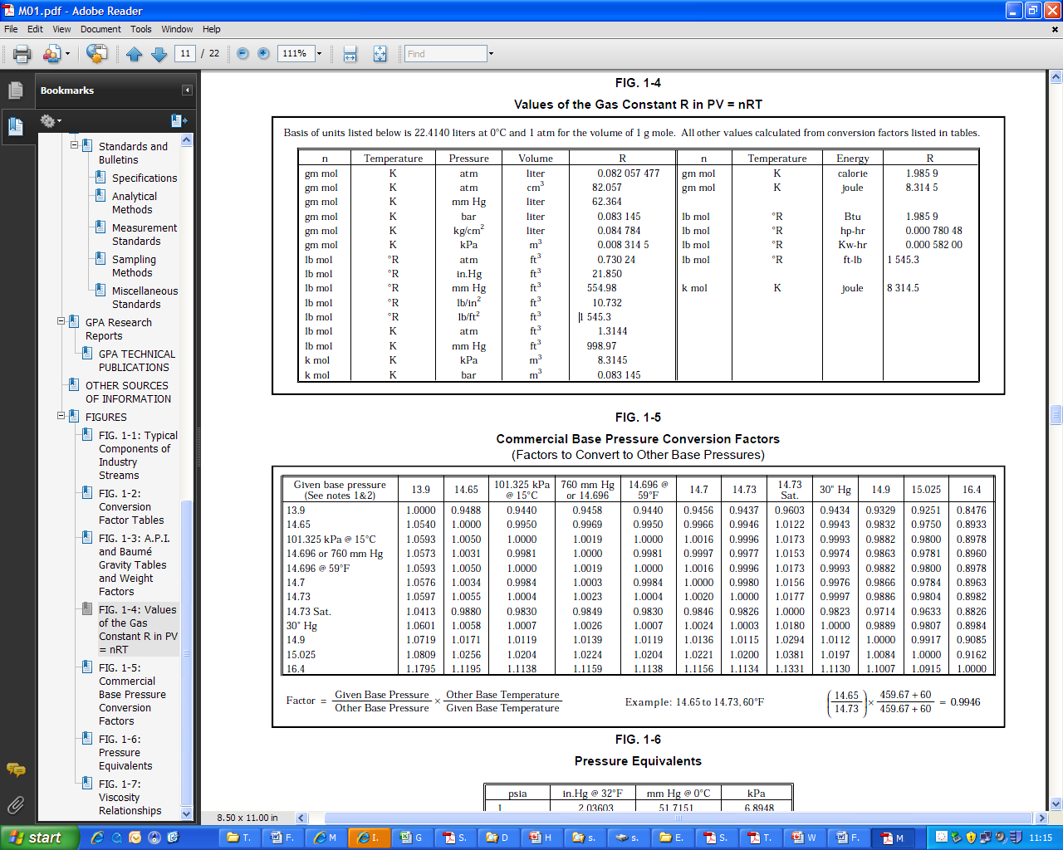

Now using Bernoulli’s for static fluid – no friction and acceleration losses.



From the ideal gas law



Substitute into above integral gives;



Hence if P1 and are known P2 can be determined.

# Flowing Fluids

## Laminar Flow

Recall from basic fluid mechanics that the velocity of fluid molecules are in the direction of flow with only minor movement across the streamlines caused by molecular diffusion.

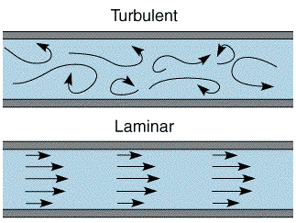

## Turbulent Flow

Here, circulating currents (eddies) cross the streamlines to give a movement of fluid molecules other than in the direction of flow.



## Reynolds Number

The Reynolds Number is frequently used to characterise and quantify aspects of fluid flow.

It is the ratio of inertial to viscous forces. Accepted transitions are;

* Laminar: Re<2000
* Turbulent Re>4,000



ρ - Fluid density

v- Fluid velocity – volume flow/pipe area

d – Pipe diameter

μ - Fluid viscosity

## Boundary Layer

When a fluid with uniform velocity flows over a surface, the fluid in contact with the surface is brought to rest and the adjacent layers are gradually retarded by the viscous properties of the fluid.

There is a velocity gradient perpendicular to the fluid flow with the velocity varying from zero at the surface (pipewall) to a maximum value in the bulk of the fluid. Due to the gradual build-up of retardation, the velocity profile changes along the surface, the region of retardation gradually increasing in thickness.

This region was called the boundary layer by Prandtl in 1949. Since the bulk velocity is approached asymptotically, the edge of the boundary layer has to be defined as a point where the fluid velocity reaches a stated percentage of its bulk. This is frequently 99%.

At the leading edge the flow in the boundary layer is laminar but after a certain distance eddies are formed, giving a turbulent boundary layer.

## Viscosity

Sir Isaac Newton (1642-1727) proposed that shear stress is proportional to the velocity gradient.

Consider fluid sandwiched between two parallel plates set apart by at a distance *dz*.

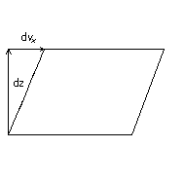



 - Shear Stress

Viscosity, μ is constant – a Newtonian Fluid

### Force Balance and Velocity Distribution

For laminar flow viscous retardation will cause velocity to vary parabolically with distance from the pipe wall.

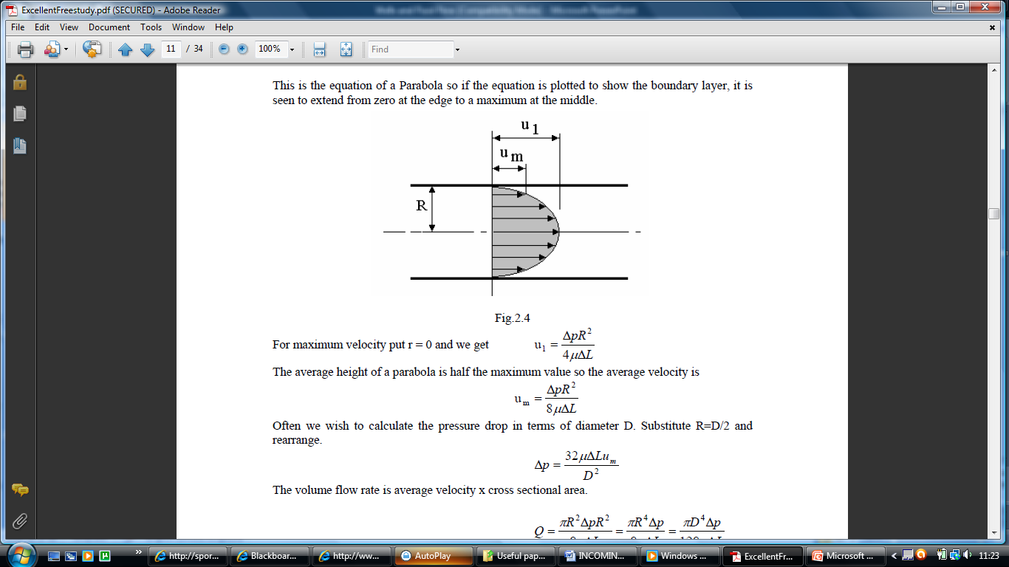

v

v

Preforming a force balance for laminar flow. Here we have pressure forces balanced by a restraining shear force.

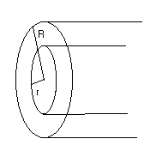



By substitution;



By integration



Equation for a parabola, at r =0, Vx = Vmax

Average of a parabola, Vave = Vmax/2

Hence,



Using average velocity;





Rearranging;



Multiply and divide RHS of above by Reynolds number;





### Turbulent Flow

Turbulent flow cannot be solved analytically and an empirical friction factor, f, is introduced.



f is the Moody friction factor for turbulent flow This equation is often termed as the Darcy Equation and is frequently used in industrial applications.

### Friction Factor and Pipe Roughness

The inside wall of a pipe is not normally smooth, and, in turbulent flow, the roughness can have a definite effect on the friction factor, and thus the pressure gradient. Wall roughness is a function of the pipe material, the method of manufacture and the environment to which it is exposed.

From a microscopic sense, wall roughness is not uniform. Individual protrusions, indentations, etc. vary in height, width, length, shape and distribution. The absolute roughness of a pipe, is the mean protruding height of relatively uniformly distributed and sized, tightly packed sand grains that would give the same pressure gradient behaviour as the actual pipe.

Dimensional analysis suggests that the effect of roughness is not due to its absolute dimensions, but rather to its dimensions relative to the inside diameter of the pipe. In turbulent flow, the effect of wall roughness has been found to be dependent on both the relative roughness and on the Reynolds number. If the laminar sublayer that exists within the boundary layer is thick enough, then the behaviour is similar to a smooth pipe

It is important to emphasize that it is not a property which is physically measured. Rather, it is the sand grain roughness which would result in the same friction factor.

Relative surface roughness is defined as

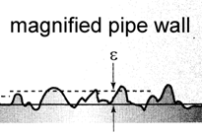ε = k/D

where k is the mean surface roughness and D is the pipe diameter.

Moody conducted exhaustive experiments on different pipe sizes and roughnesses, from which the famous Moody chart was developed. This is a plot friction factor against Reynolds number for various values of ε.

Simplifications of the chart have been made for smooth pipe;

Blasius f = 0.316/Re0.25

Lee f = 0.0072 + 0.608/Re0.35

**Moody Chart – Friction Factor and Relative Roughness**

The following Moody chart is frequently used to determine friction factor.

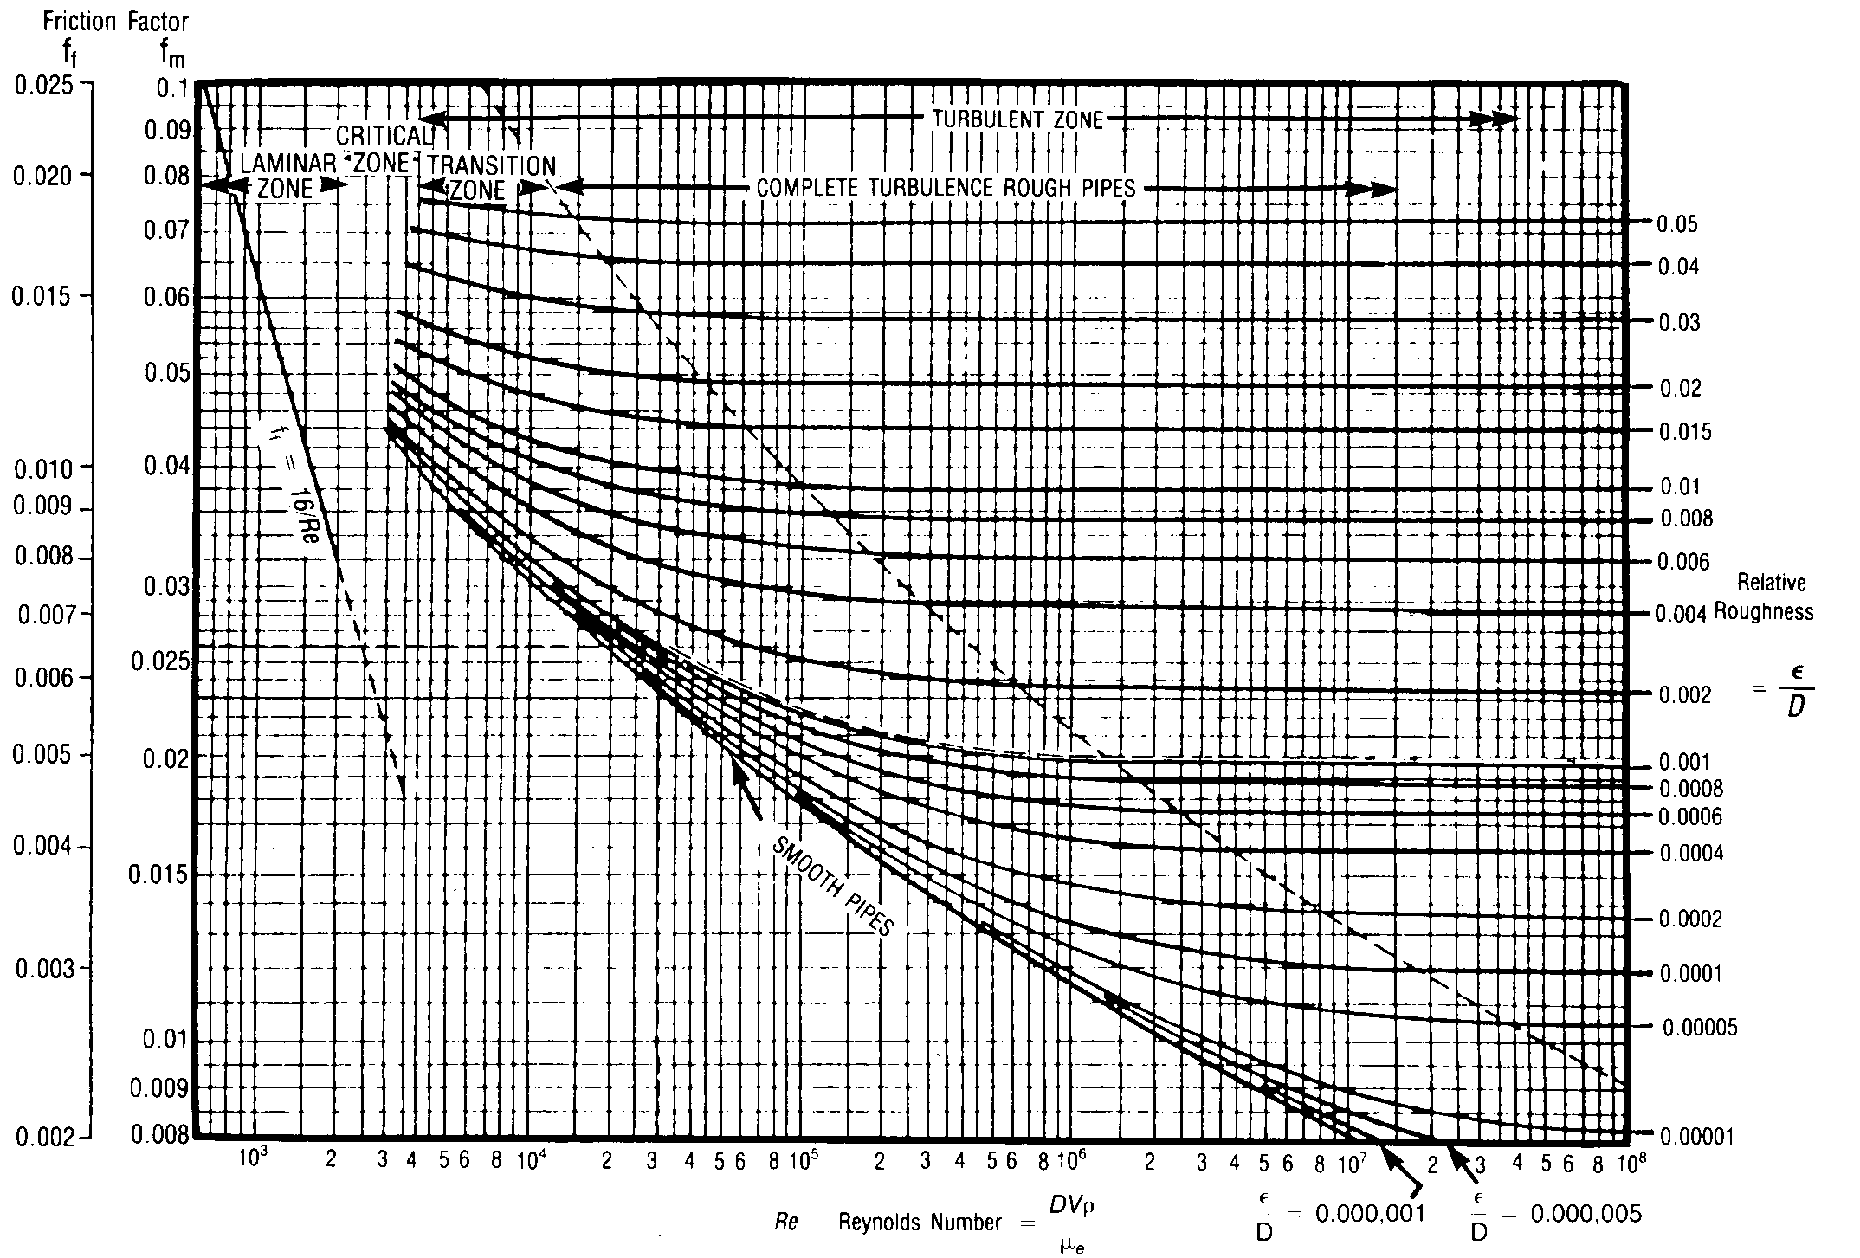

Fanning Moody

To use the chart Relative Roughness has to be determined. This is done using a Roughness Chart as follows.

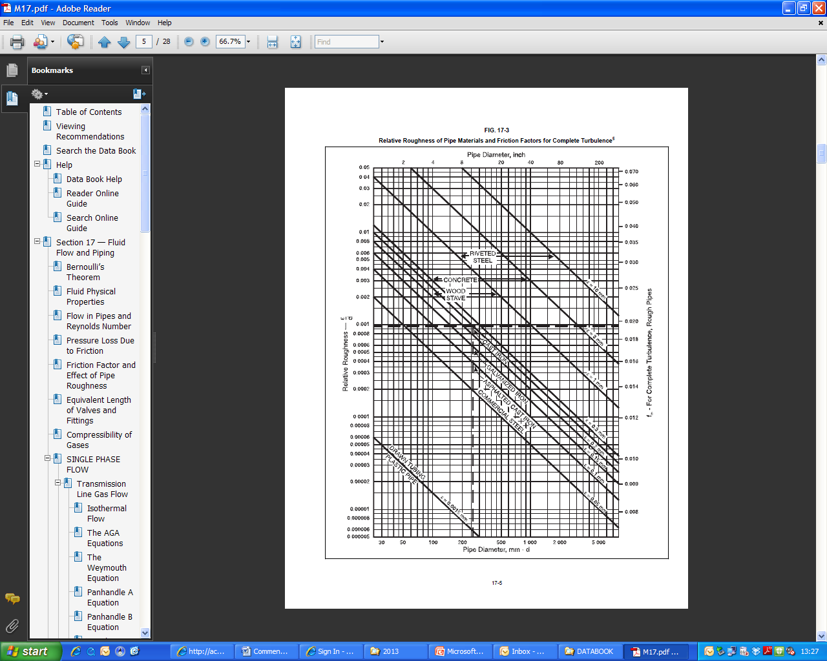

### Equivalent Length

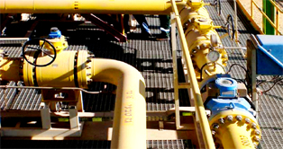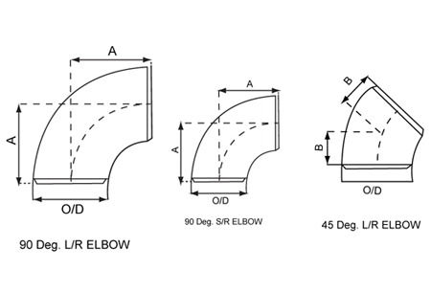The concept equivalent length is used to estimate the pressure drop across a range of pipework components and valves. A length is attributed to the component to give an equivalent pressure drop. Some common Equivalent Lengths are shown – these are expressed as length/diameter ratios.

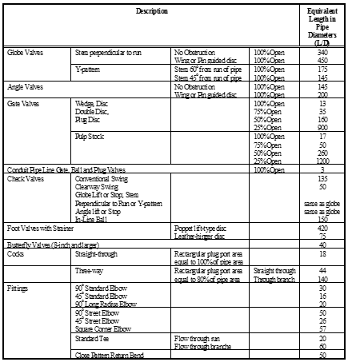

**Worked Example**

15,000 bpd of oil (ρ = 800 kg/m3, μ = 3 cP) flows from A to B (D = 0.1 m, relative roughness = 0.0005). Calculate the frictional pressure loss.

3/4 Opened Double

Disc Gate Valve

5 m

15 m

2 m

10 m

90o Standard Elbow

Standard Tee

A

B

Calculate the equivalent lengths (Le ) from table:

3/4 opened gate valve: L/D = 35

Le = 35 * 0.1 = 3.5 m

90o elbow: L/D = 30

Le = 30 * 0.1 = 3.0 m

Through branch tee: L/D = 60

Le = 60 * 0.1 = 6.0 m

Total length for pressure loss calculation:

5 + 3.5 + 15 + 3.0 + 2 + 6.0 + 10 = 44.5 m

Calculate the fluid velocity:



Calculate Reynolds number:



Find the friction factor from the Moody chart: f = 0.02

Calculate the frictional pressure loss using Darcy’s equation:



### K Factors

An alternative to Equivalent Length is the use of K factors.

In Darcy’s formula



the term



can be expressed as the number of “velocity heads” K giving: frictional pressure loss:



K factors can be attributed to all flow restrictions e.g. valves, fittings, pipes with a different diameter from a reference pipe diameter, pipe contractions, pipe enlargements etc..

As all K factors of specific restrictions can be adjusted to relate to the same diameter, the individual K-coefficients can be added up to give a total K-coefficient, enabling the calculation of frictional pressure losses in complex piping systems (similar to the equivalent length concept).

Some useful relations are:



K in terms of another pipe diameter



Sudden Enlargement



Sudden Contraction

A Technical Paper on these issues, widely used and accepted by industry is:

**“Flow of Fluids through Valves, Fittings, and Pipe”, Technical Paper No. 410M, CRANE**

Another way of expressing a K factor for a fitting utilises multipliers of the fully turbulent friction factor.

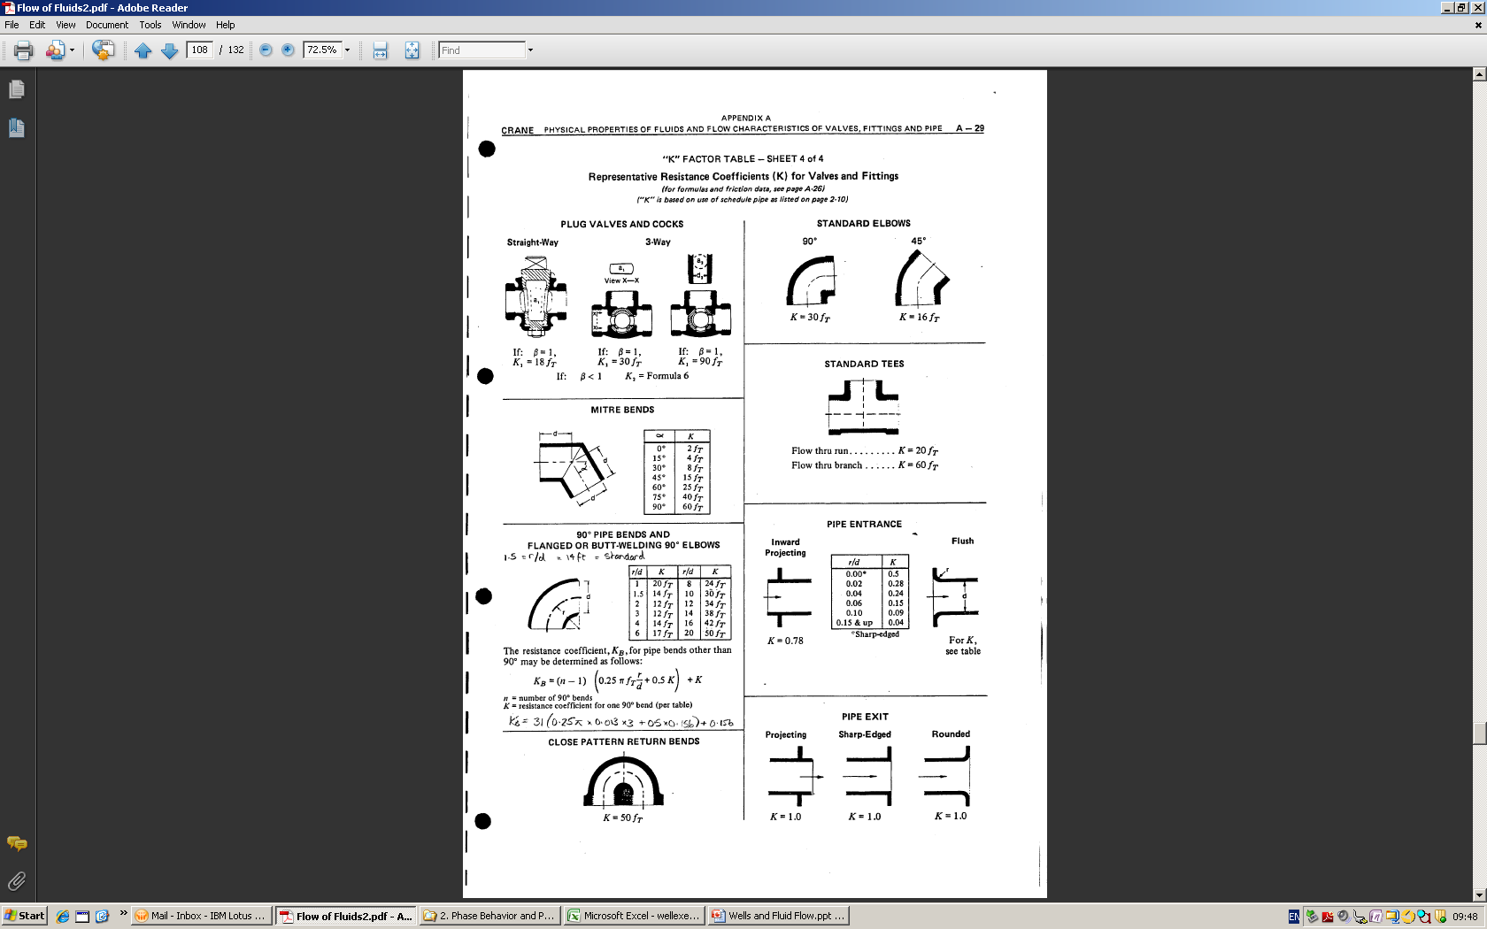

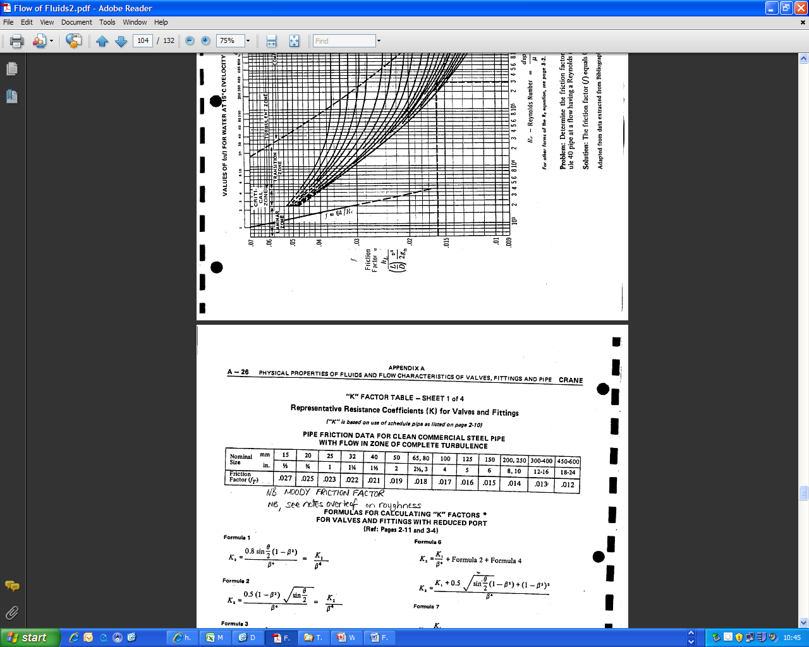

Β is the ratio of small to large diameter of the component.

### Approximate Line Sizing

The following guidelines are often used for preliminary estimates:



When undertaking calculations the student should always reflect on calculation results. Does the calculated velocity, pipe diameter seem reasonable?

## Control Valves

Control valves for pressure, flow, level, temperature control are used extensively in process plant. By its nature a control valve induces a pressure drop to facilitate control. Hence predicting pressure drop through a control valve is very important. All control valves will have an associated CV. The CV provides a basis for estimating pressure drop.

The generalised liquid sizing formula is as follows;

CV=Q. √(G/ΔP)

Where;

CV =liquid flow coefficient (valve characteristic)

Q = Flow,USGPM (USgallon per minute)

G = Liquid SG

ΔP = Pressure drop across valve, psi

For gases the Cv expression is much more complex.

A typical valve data sheet is shown with required Cv is shown (line 18);

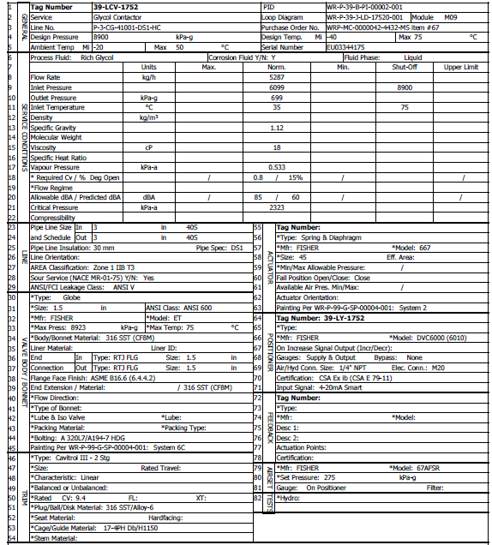

# Compressible Flow Pressure Drop

In this situation density and pressure are related hence the integral ∫ has to be solved.

This can be undertaken by substituting the gas law into the relation





The following expression – the General Gas Equation can be developed.



Other expressions used by industry are shown;

Where;

qsc gas rate at Tsc, Psc (m3/d or scfd)

P absolute pressure (kPa or psia)

Psc pressure stand. cond. (kPa or psia)

Tm pipe mean temperature (K or oR)

Pm pipe mean pressure (kPa or psia)

Tsc temp. stand. cond. (K or oR)

Tg temp. pipe surroundings (K or oR)

D pipe internal diameter (m or in.)

ε absolute roughness (m or in.)

L pipe length (m or mile)

γ gas relative density (-)

zm mean compressibility factor (-)

f Fanning friction factor (-)

E pipeline efficiency (-)

Re Reynolds number (-)

Ft transmission factor (1/√(1/f)

Ff drag factor (-)

E, Pipeline efficiency is generally between 1 and 0.9. It reflects increased roughness perhaps due to corrosion or an attempt to account for liquid formation.

γ, Gas Relative Density – relative to air. It is the molecular weight of the gas divided by the molecular weight of air (29). For mixed gases the average molecular weight requires to be calculated.

Typical compressible gas flow piping information is shown.



Recommended Pressure Drop for Vapour Lines



Allowable Gas Velocities for Vapour Lines

# Flow through an Orifice

Orifice plates are used as flow measurement devices where flow is correlated to the pressure drop across the orifice. They are also used as flow restriction devices, for example to limit the gas rate to a flare system.

*P1*

*P2*

*do*

*d1*

Orifices and nozzles are used principally to meter a rate of flow. The pressure drop across a profiled orifice plate can be translated to a flow rate utilising the following information. Orifices are also used to restrict flow and to reduce pressure.

The general expression for flow through an orifice is written as

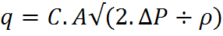

C values may be taken from the following figures.

For the flow of compressible (gas) fluids an expansion factor requires to be introduced.

The expansion factor Y is a function of the heat capacity ratio, pressure ratio and orifice geometry.

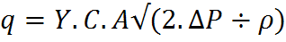

q – m3/s

A – m2 (of orifice)

P – pascals

ρ – kg/m3

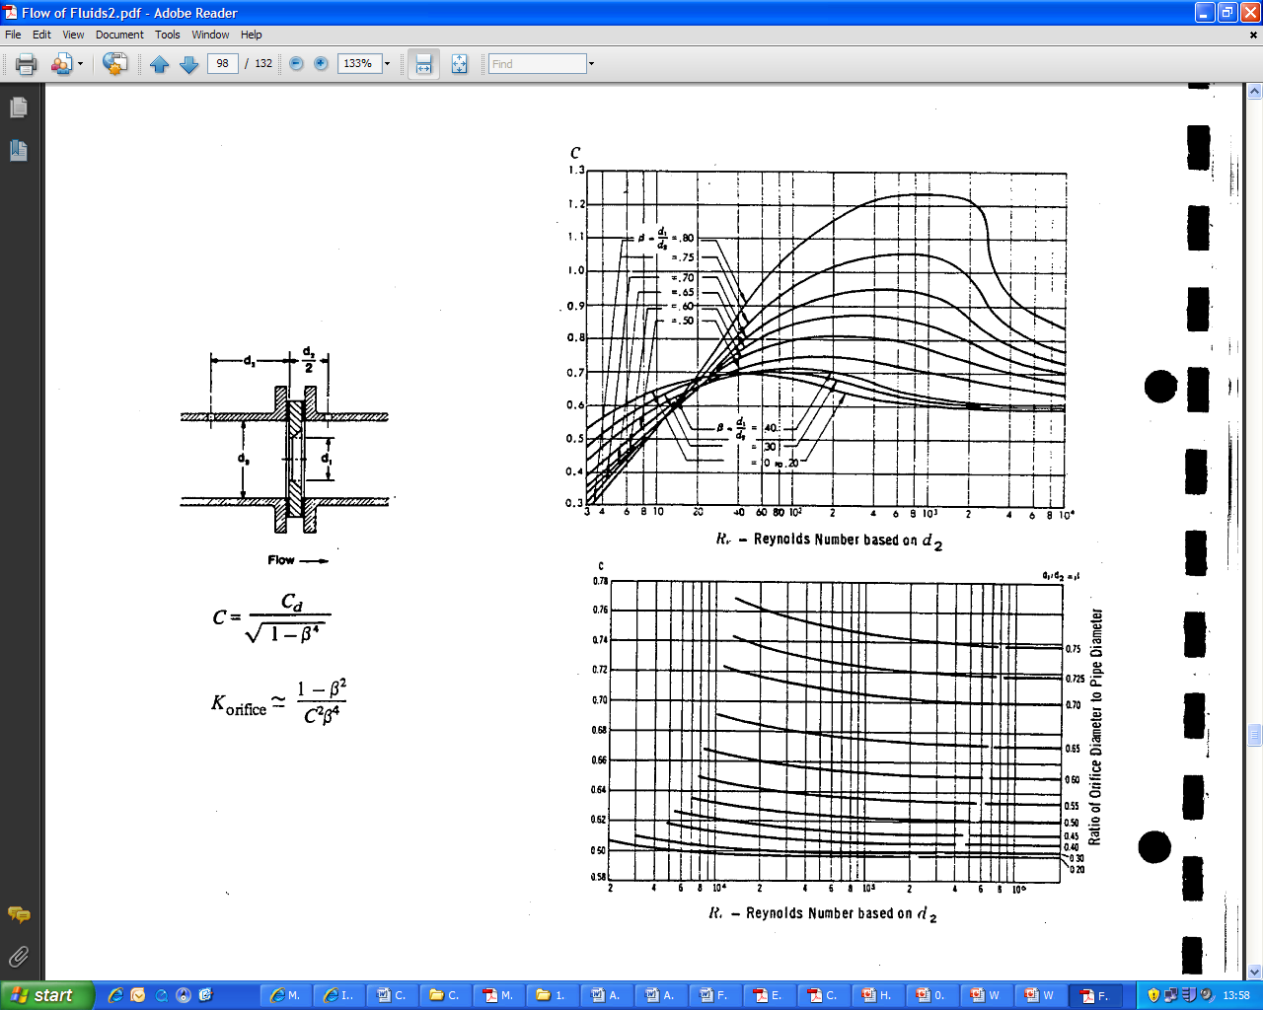

Beta is diameter ratio – small to large



# Choke/Critical/Sonic Flow

Choke flow can occur in process pipework. It commonly occurs with compressible flow where a 2:1 (approx.) pressure expansion occurs across a component e.g. relief valve.

For an ideal gas it can be shown that the speed of sound c (m/s) is;

Where;

k = ratio of specific heats, Cp /Cv

R = universal gas constant, (8314 J/kgmol K)

T = absolute temperature, DegK

Mw = molecular weight

Consider the above arrangement where a gas filled vessel is at pressure P1 - significantly higher than atmospheric pressure. A vent pipe is opened, hence the vessel will depressurise to the atmosphere. As the gas moves from the vessel to the vent outlet there will be a pressure drop due to friction, elevation and acceleration. If P2/P3 is less than 0.55 (approx.) the gas velocity at the vent opening will be sonic at pressure P2.

P1

P2

P3

P1 Vessel Pressure

P2 Pressure immediately upstream of pipe opening

P3 Atmospheric Pressure

Vent Pipe

P2

# Surge

Water hammer (or, more generally, fluid hammer) is a pressure surge or wave caused by the kinetic energy of a fluid in motion when it is forced to stop or change direction suddenly. It depends on the fluid compressibility where there are sudden changes in pressure. For example, if a valve is closed suddenly at an end of a pipeline system a water hammer wave propagates in the pipe. Moving water in a pipe has kinetic energy proportional to the mass of the water in a given volume times the square of the velocity of the water.

Possible causes are;

* Pump trip or start
* Valve closure or opening
* Non Return (check) valve or one-way valve - allows fluid (liquid or gas) to flow through in one direction only.

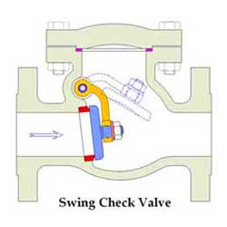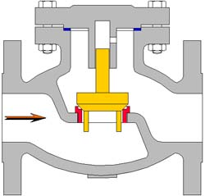

## Joukuowsky Equation

The pressure change ΔP in a fluid caused by an instantaneous change in flow velocity, Δv, is calculated by:

ΔP = Δv . ρ . a

Where;

Δv : Flow velocity change in m/s

ρ: Density of the fluid in kg/m3

a: Wave propagation velocity through the fluid in the pipeline in m/s

ΔP : pressure change in N/m2

The ΔP formula is referred to as the Joukuowsky equation. It applies if the time (Tr ) that Δv occurs in is less than the transit time for a pressure wave to travel up and down the pipeline.

Joukuowsky conducted a series of experiments on Moscow drinking water supply pipes. He published the results of his work in 1898.

Wave propagation velocity (speed of sound in a liquid) is given by;

a = √(E/ρ)

E – liquid bulk modulus (Pa)

ρ – liquid density (kg/m3)

Hence for water, a = √(K/ρ) = √(2.15x109/1000) = 1466 m/s

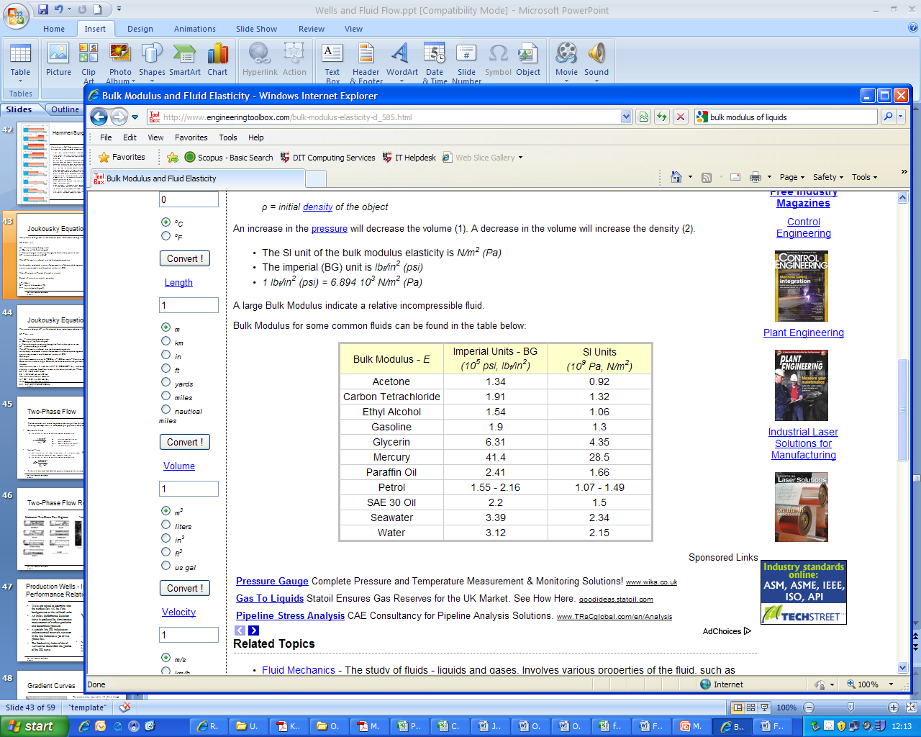

## Surge in Pipelines

If the liquid pumped is highly viscous or if the pipeline is extremely long (100 km and more), often the case in oil pipelines a further pressure phenomena takes place. If a valve is closed rapidly at the end of a pumped pipeline the Joukuowsky equation will underestimate the actual pressure surge.

The phenomenon is caused by the pipe friction. In normal operation the pump is overcoming pipe friction, when the flow is stopped by the closing valve, friction losses are not evident and the pump discharge pressure is applied along the length of the pipe. At the end of the pipe the pressure increase as a result of the Joukuowsky together with the friction effects.

Analysis of an oil pipeline often requires a more thorough analysis than the Joukuowsky head. Detailed analysis is undertaken with specialist software and incorporates the deformation of the pipe. A typical pipeline surge may look like the adjacent figure.

Surge valves and surge tanks are common features in pipeline reception systems.

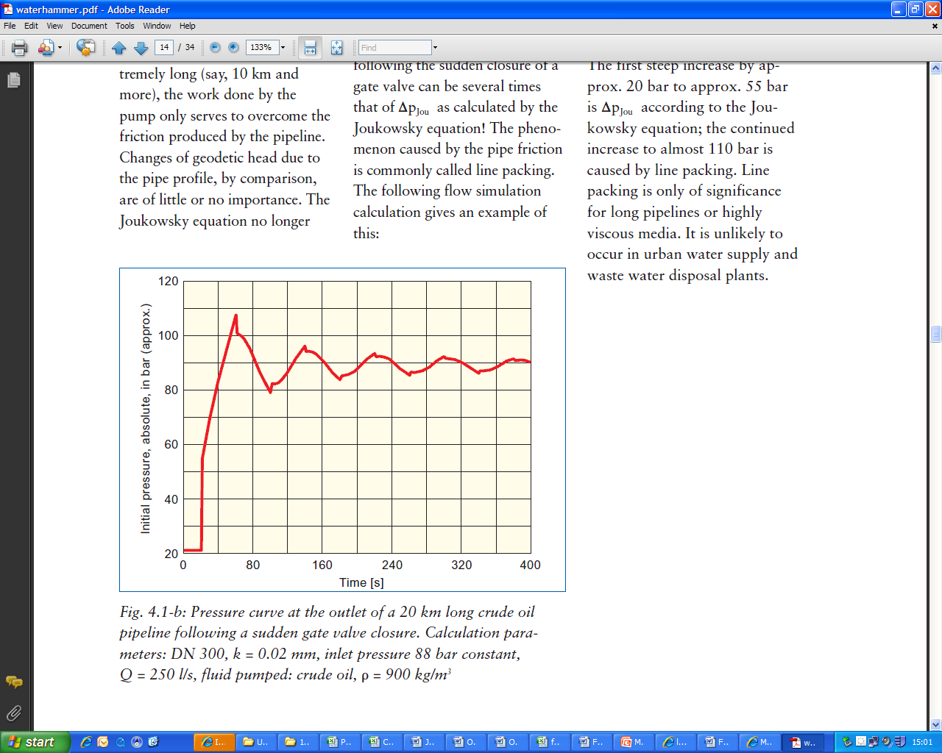

Joukowsky head

Friction

The loading and unloading of tankers with petrochemical fluid ranging from crude oil to cryogenic LNG is a daily occurrence throughout the world. However, it is an operation that has to be carefully designed due to the combination of high flow rates and relatively short distances. Industry regulations require transfer flow to be stopped rapidly in the event of any emergency, which often means valve closures of around 5s and the generation of high and rapidly applied surge pressures / pipe loads.

The problems encountered in a typical ship transfer system will include:

* Excessive surge pressures caused by Ship ESD Valve closure causing damage to loading hoses or arms, loading buoy and feed pipework.
* High surge pressures caused by closure of Marine Breakaway Couplings.
* 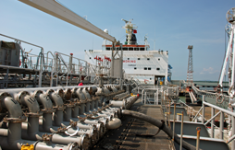Low pressures and possible vapour pocket formation following unplanned pump trip.
* High pressures during pump start up, particularly of concern if there are any vapour pockets formed during the connection which will lead to high pipe forces.
* Check valve slam at the pumps or along the system during rapid flow changes.
* Excessive pipe loads and pipe movement caused by high pressures and rapid pressure changes.

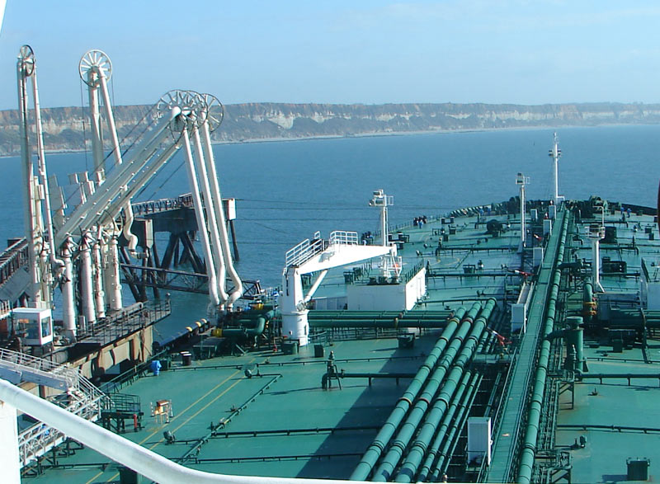

# Pipeline Column Separation

A related phenomena is column separation. Here a region of low pressure caused by a flow disturbance is generated. The liquid is said to separate leaving a vapour void. The inside to outside pressure forces reverse with external atmospheric pressure causing the pipeline to collapse.

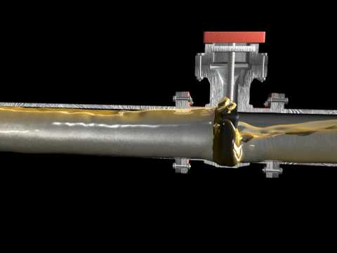

# Key Learnings

Three components of pressure loss – friction, elevation, acceleration

Laminar, turbulent flow, Reynolds number and friction factor

Derivation of Darcy Formula

Application of Bernoulli’s equation

Compressible and incompressible flow

Concept of equivalent length and K factors

Flow through an orifice

Surge and choke flow

Flow separation

# Reading List

Perry, Chemical Engineer’s Handbook

Massey, Mechanics of Fluids

Flow of Fluids, Crane Manual, Technical Paper 410M